1. **AZURE SQL**

-- Question 1: Total sales $

**Select** **sum**(UnitPrice*Quantity) **as** Sales **from** [Nikita-SQL-Database].chinook.InvoiceLine;

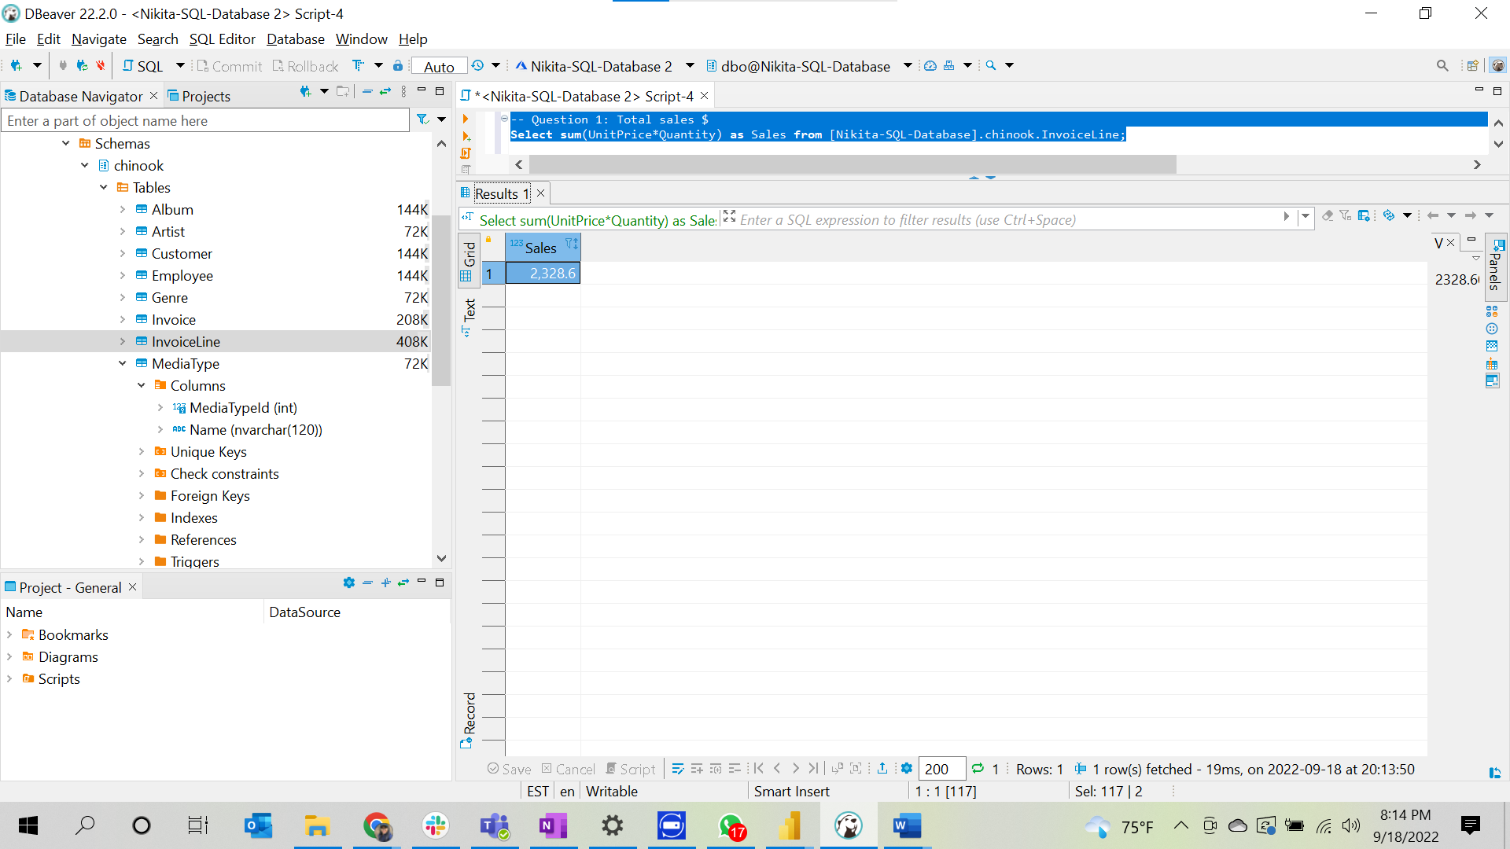

--Question 2: Total sales $ by country – ranked (or at least sorted largest to smallest)

**Select** invo.BillingCountry **as** Country, **sum**( involi.Quantity * involi.UnitPrice ) **as** SalesByCountry

**from** [Nikita-SQL-Database].chinook.InvoiceLine involi

**join** [Nikita-SQL-Database].chinook.Invoice invo **on** invo.InvoiceId = involi.InvoiceId

**group** **by** invo.BillingCountry

**order** **by** SalesByCountry **desc**;

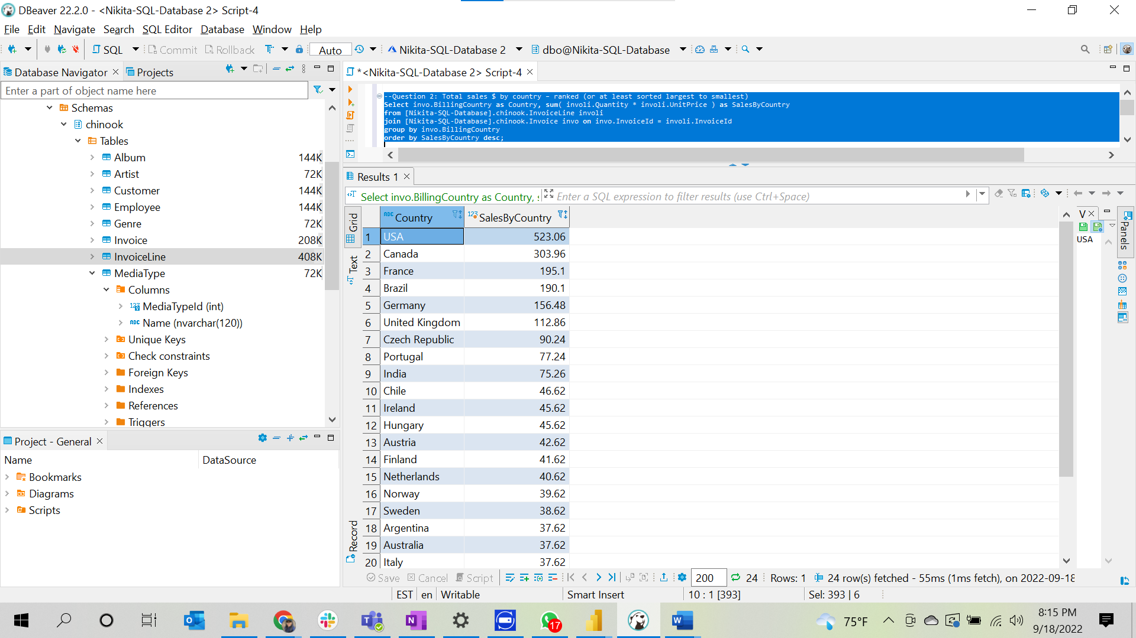

--Question 3: Total sales $ by country, state & city

**Select** invo.BillingCountry **as** Country,

**case** **when** invo.BillingState **is** **null** **then** invo.BillingCity

**else** invo.BillingState **end** State

, invo.BillingCity City,

**sum**( involi.Quantity * involi.UnitPrice ) SalesByCountryStateCity

**from** [Nikita-SQL-Database].chinook.InvoiceLine involi **join**

[Nikita-SQL-Database].chinook.Invoice invo **on** invo.InvoiceId = involi.InvoiceId

**group** **by** invo.BillingCountry,

**case**

**when** invo.BillingState **is** **null** **then** invo.BillingCity

**else** invo.BillingState **end**

, invo.BillingCity

**order** **by** State,SalesByCountryStateCity **desc**;

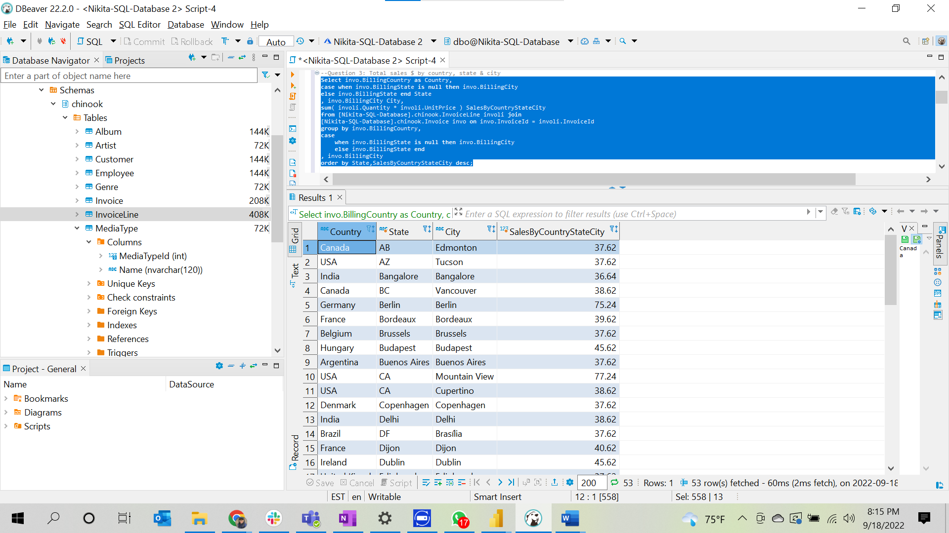

--Question 4: Total sales $ by customer (a person with last name & first name) – ranked (or at least sorted largest to smallest)

**Select** (cust.LastName + ', ' + cust.FirstName ) **as** FullName, **sum**(involi.Quantity * involi.UnitPrice) **as** SalesByCustomer

**from** [Nikita-SQL-Database].chinook.InvoiceLine involi **join** [Nikita-SQL-Database].chinook.Invoice invo

**on** involi.InvoiceId = invo.InvoiceId

**join** [Nikita-SQL-Database].chinook.Customer cust

**on** cust.CustomerId = invo.CustomerId

**group** **by** (cust.LastName + ', ' + cust.FirstName)

**order** **by** **sum**(involi.Quantity * involi.UnitPrice) **desc**;

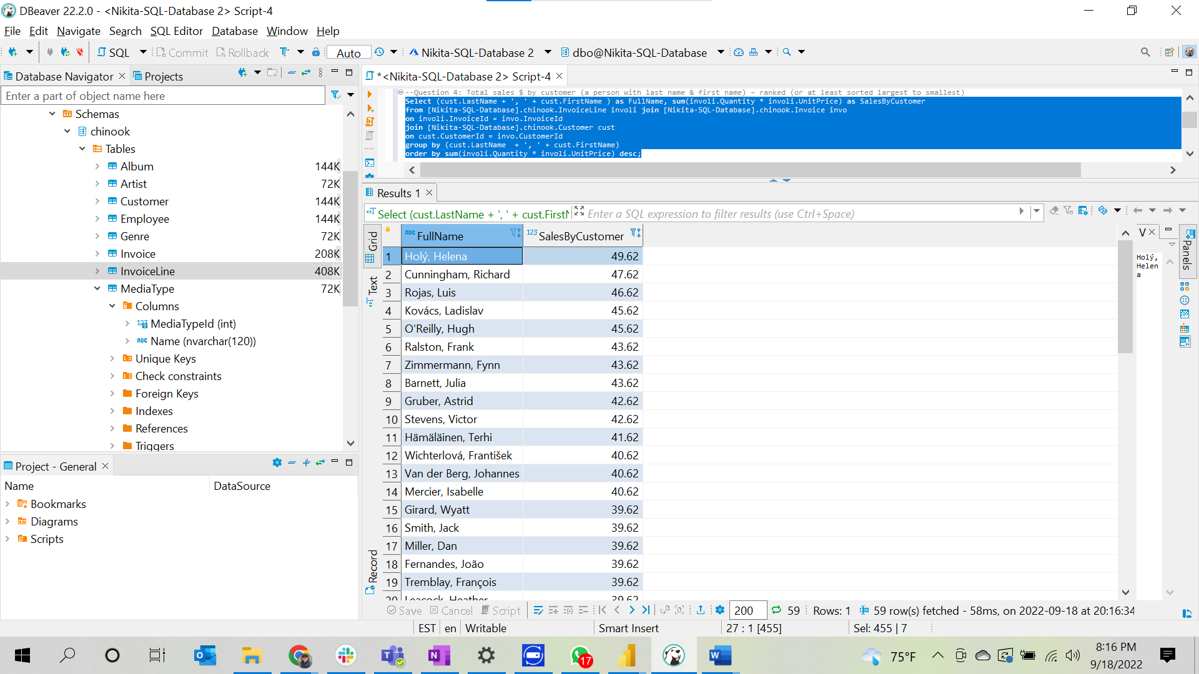

--Question 5. Total sales $ by artist – ranked (or at least sorted largest to smallest)

**Select** art.Name **as** ArtistName, **sum**(involi.UnitPrice * involi.Quantity) **as** SalesByArtist

**from** [Nikita-SQL-Database].chinook.Artist art **join** [Nikita-SQL-Database].chinook.Album ab **on** art.ArtistId = ab.ArtistId

**join** [Nikita-SQL-Database].chinook.Track tr **on** tr.AlbumId = ab.AlbumId

**join** [Nikita-SQL-Database].chinook.InvoiceLine involi **on** involi.TrackId = tr.TrackId

**group** **by** art.Name

**order** **by** SalesByArtist **desc**;

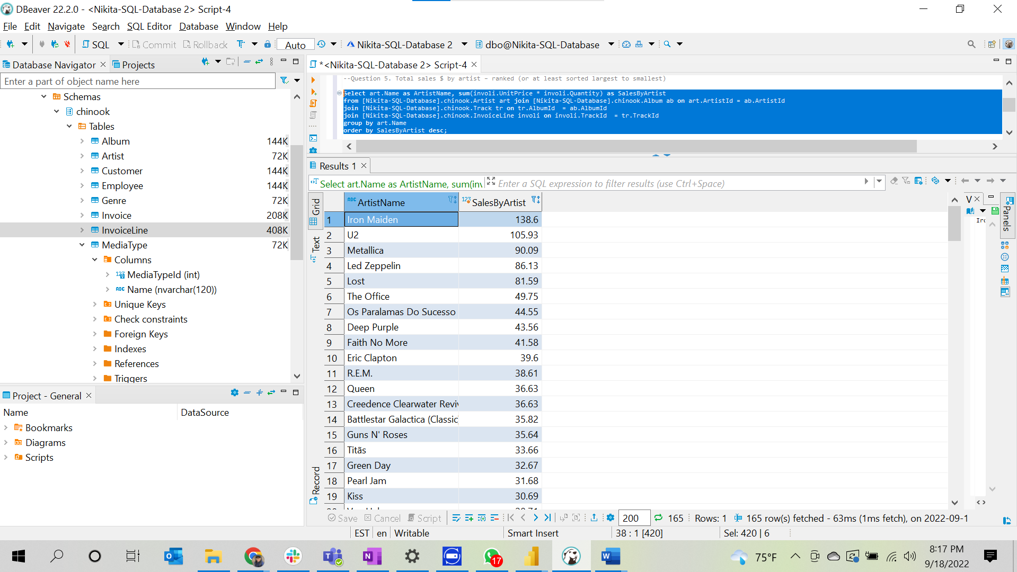

--Question 6. Total sales $ by albums

**Select** ab.Title **as** Album_Name,**sum**(involi.UnitPrice * involi.Quantity) SalesByAlbum

**from** [Nikita-SQL-Database].chinook.Album ab **join** chinook.Track tr **on** ab.AlbumId = tr.AlbumId

**join** [Nikita-SQL-Database].chinook.InvoiceLine involi **on** involi.TrackId = tr.TrackId

**group** **by** ab.Title

**order** **by** SalesByAlbum **desc**;

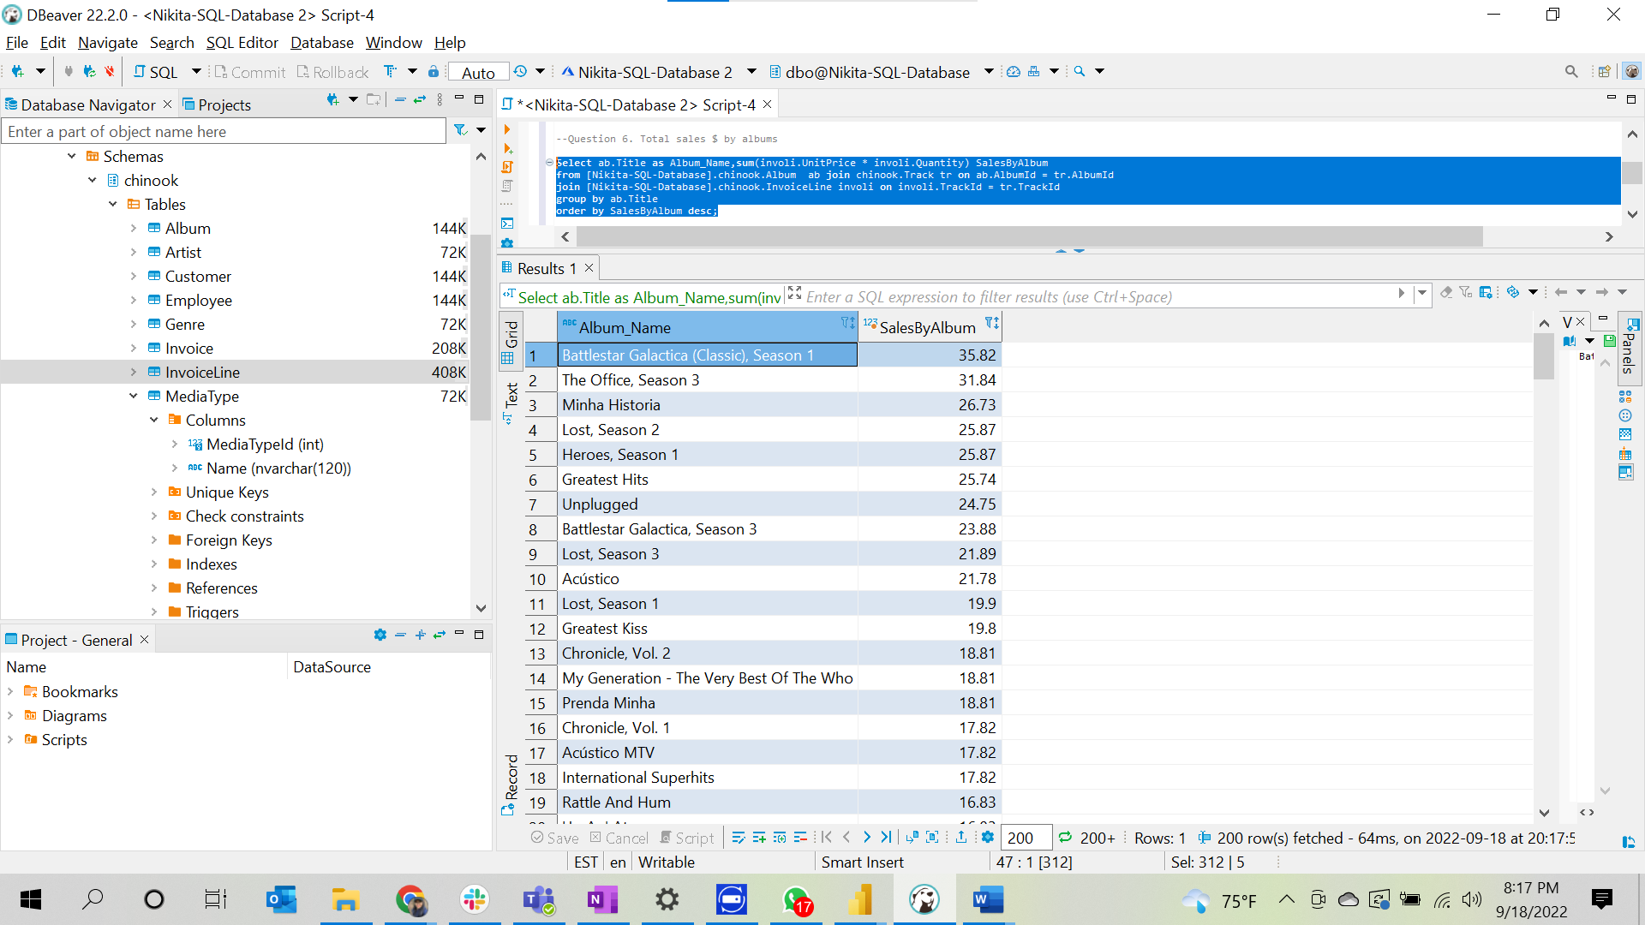

--Question 7. Total sales $ by salesperson (employee)

**Select** (emp.LastName + ', ' + emp.FirstName ) **as** SalesPerson, **sum**(involi.UnitPrice * involi.Quantity) SalesBySalesperson

**from** [Nikita-SQL-Database].chinook.Employee emp **join** [Nikita-SQL-Database].chinook.Customer cust **on** emp.EmployeeId = cust.SupportRepId

**join** [Nikita-SQL-Database].chinook.Invoice invo **on** invo.CustomerId = cust.CustomerId

**join** [Nikita-SQL-Database].chinook.InvoiceLine involi **on** involi.InvoiceId = invo.InvoiceId

**group** **by** (emp.LastName + ', ' + emp.FirstName )

**order** **by** SalesBySalesperson **desc**;

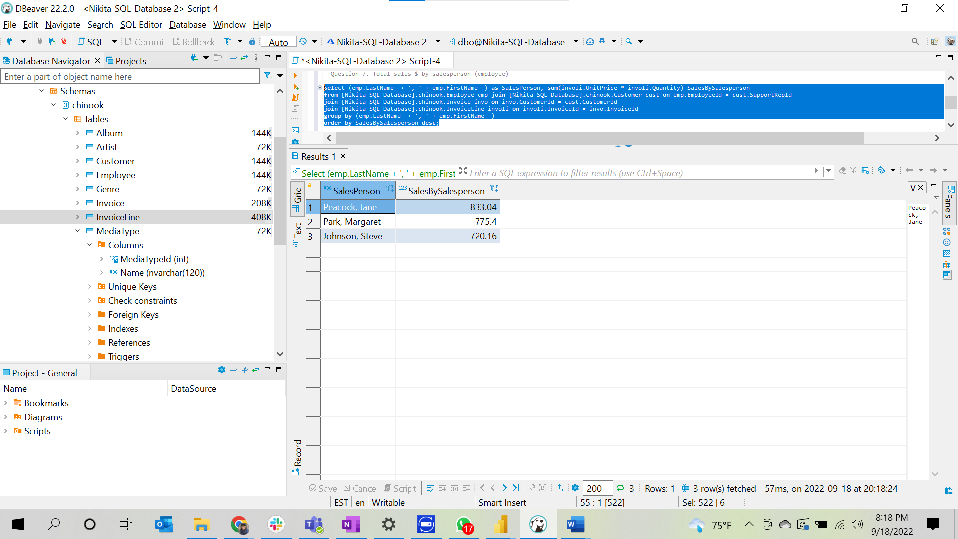

-- Question 8: Total tracks bought and total revenue $ by media type

**Select** mt.Name **as** MediaType, **SUM**(il.Quantity*il.UnitPrice) **as** Sales, **SUM**(il.Quantity)

**from** [Nikita-SQL-Database].chinook.MediaType mt **join** [Nikita-SQL-Database].chinook.Track t **on** mt.MediaTypeId = t.MediaTypeId **join** [Nikita-SQL-Database].chinook.InvoiceLine il **on** t.TrackId = il.TrackId

**group** **by** mt.Name, il.Quantity ;

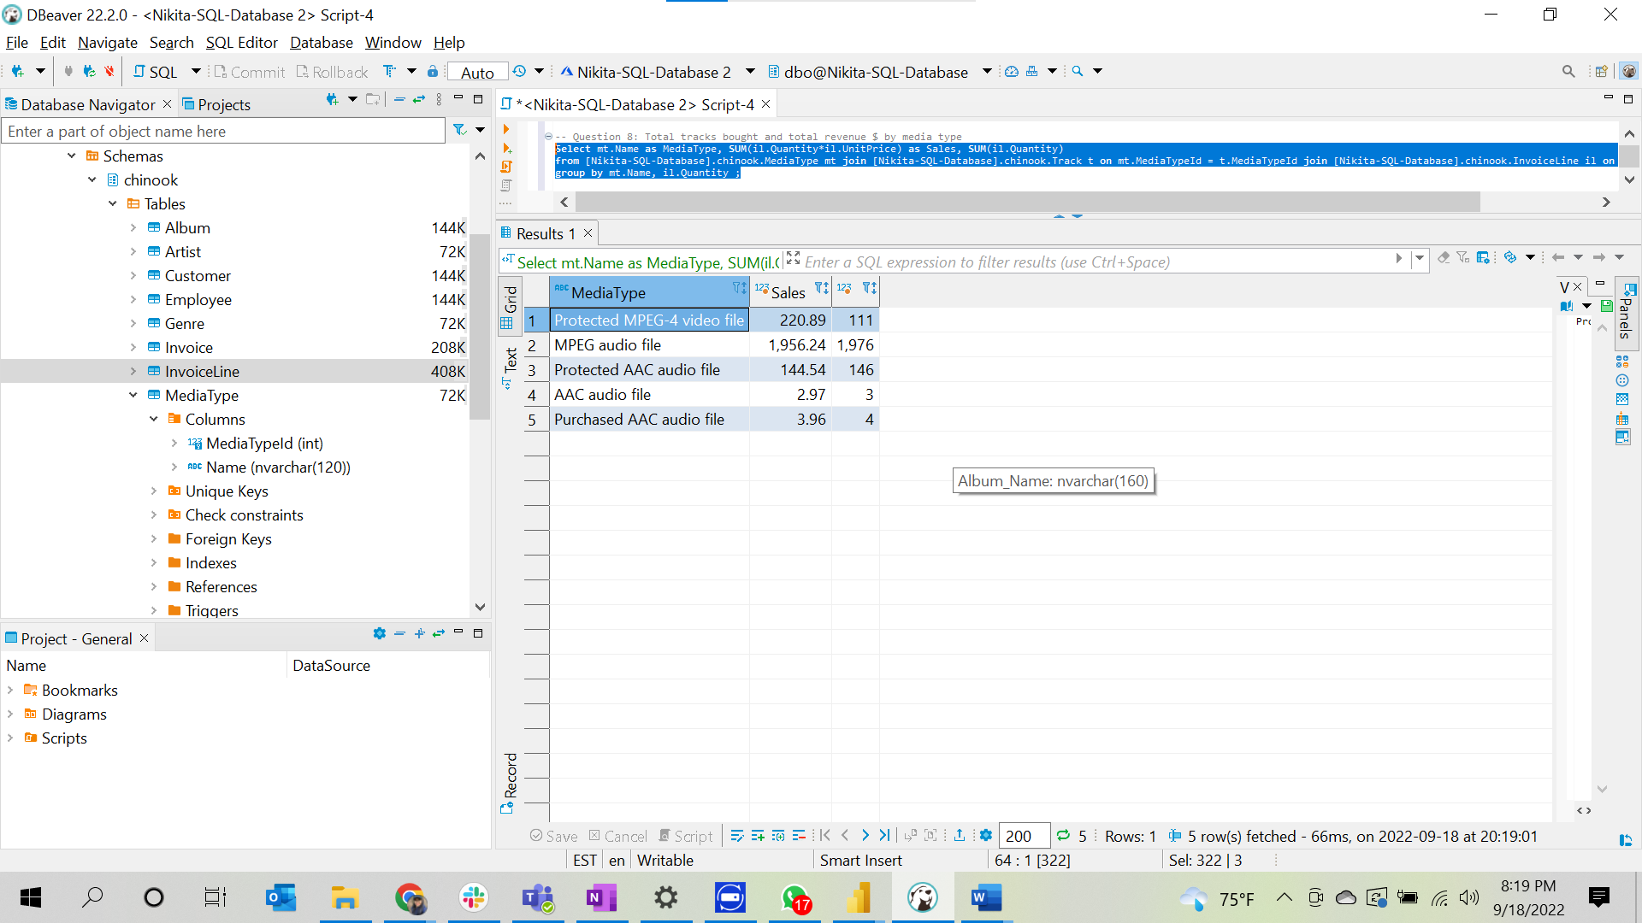

--Question 9: Total sales $ by genre

**Select** gen.Name **as** GenreName, **SUM**(involi.Quantity * involi.UnitPrice) **as** SalesByGenre

**from** [Nikita-SQL-Database].chinook.Genre gen

**join** [Nikita-SQL-Database].chinook.Track t **on** gen.GenreId = t.GenreId

**join** [Nikita-SQL-Database].chinook.InvoiceLine involi **on** t.TrackId = involi.TrackId

**group** **by** gen.Name;

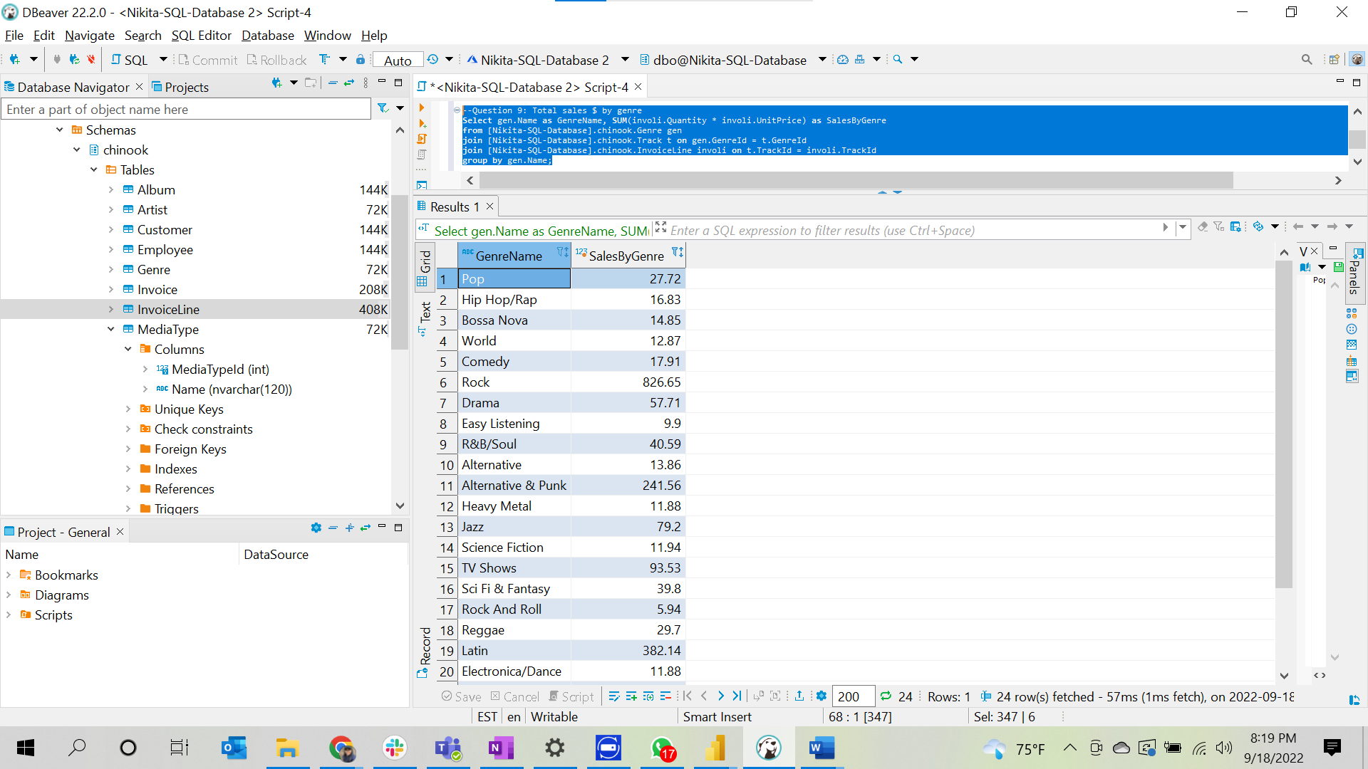

--Question 10: Total sales $ by company

**Select** cus.Company **as** Company_Name, **sum**(involi.UnitPrice * involi.Quantity) SalesByCompany

**from** [Nikita-SQL-Database].chinook.Customer cus

**join** [Nikita-SQL-Database].chinook.Invoice invo **on** cus.CustomerId = invo.CustomerId

**join** [Nikita-SQL-Database].chinook.InvoiceLine involi **on** involi.InvoiceId = invo.InvoiceId

**where** cus.Company **is** **not** **null**

**group** **by** cus.Company

**order** **by** SalesByCompany **desc**;

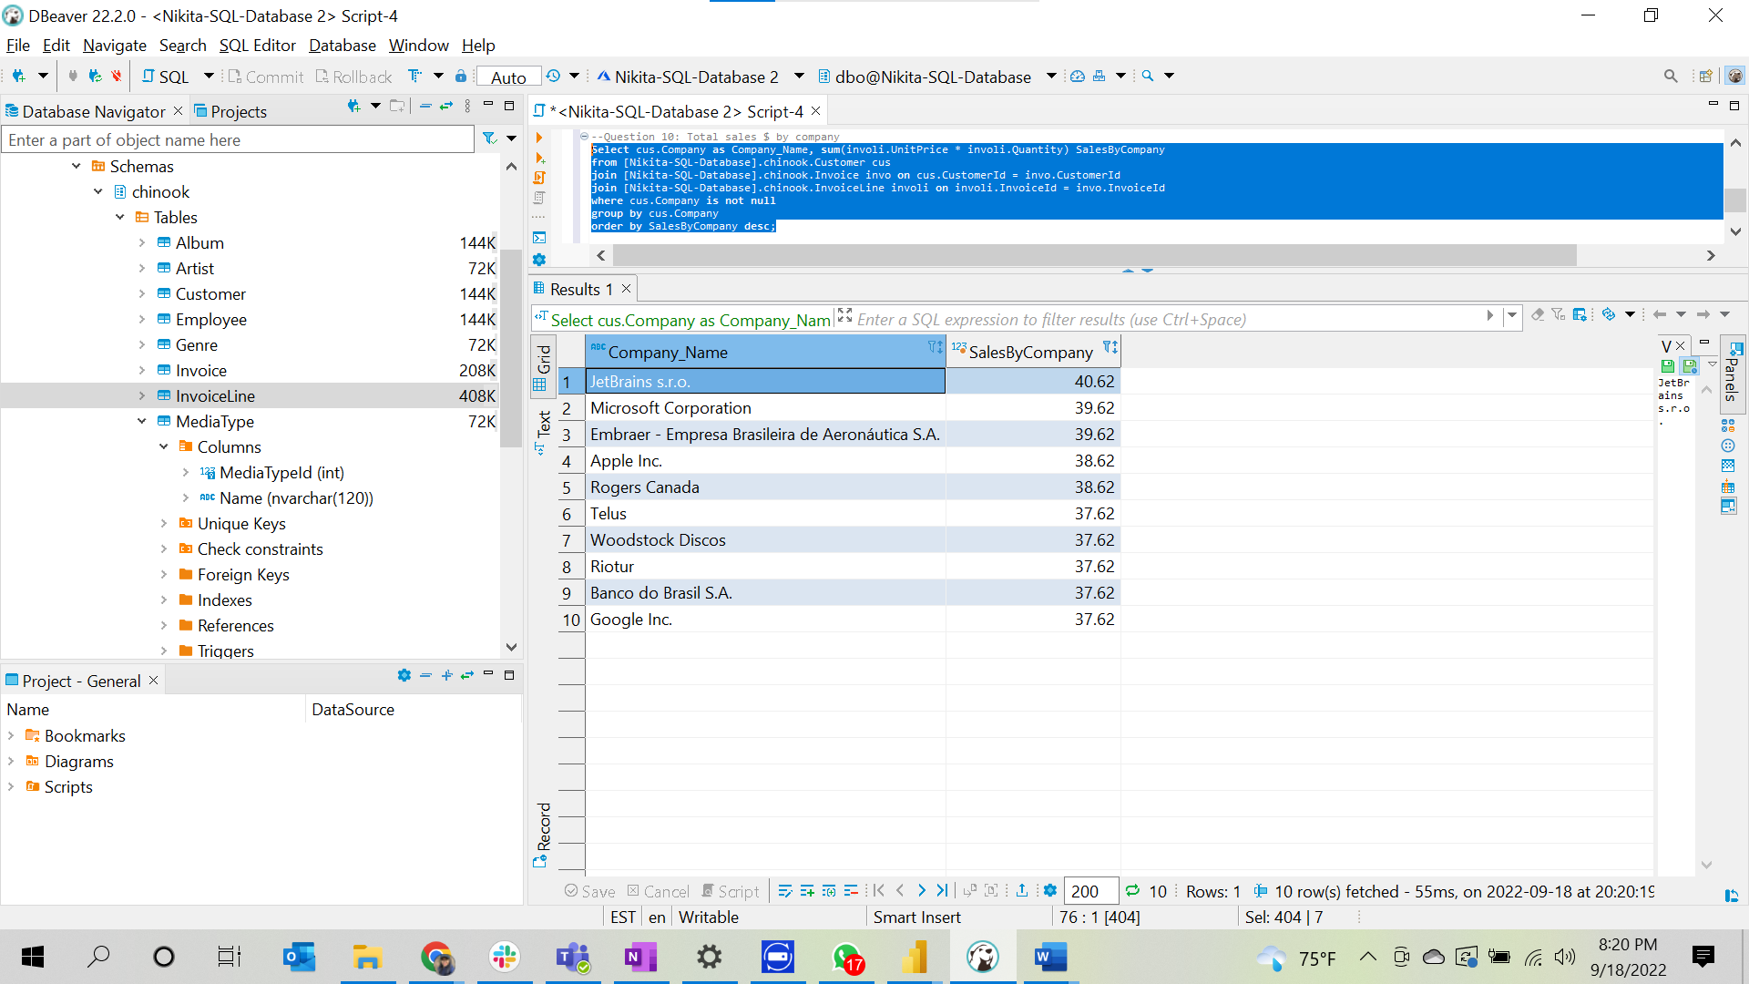

1. **MySQL Database Server**

-- Question 1: Total sales $

**Select** **sum**(UnitPrice*Quantity) **as** Sales **from** chinook.InvoiceLine;

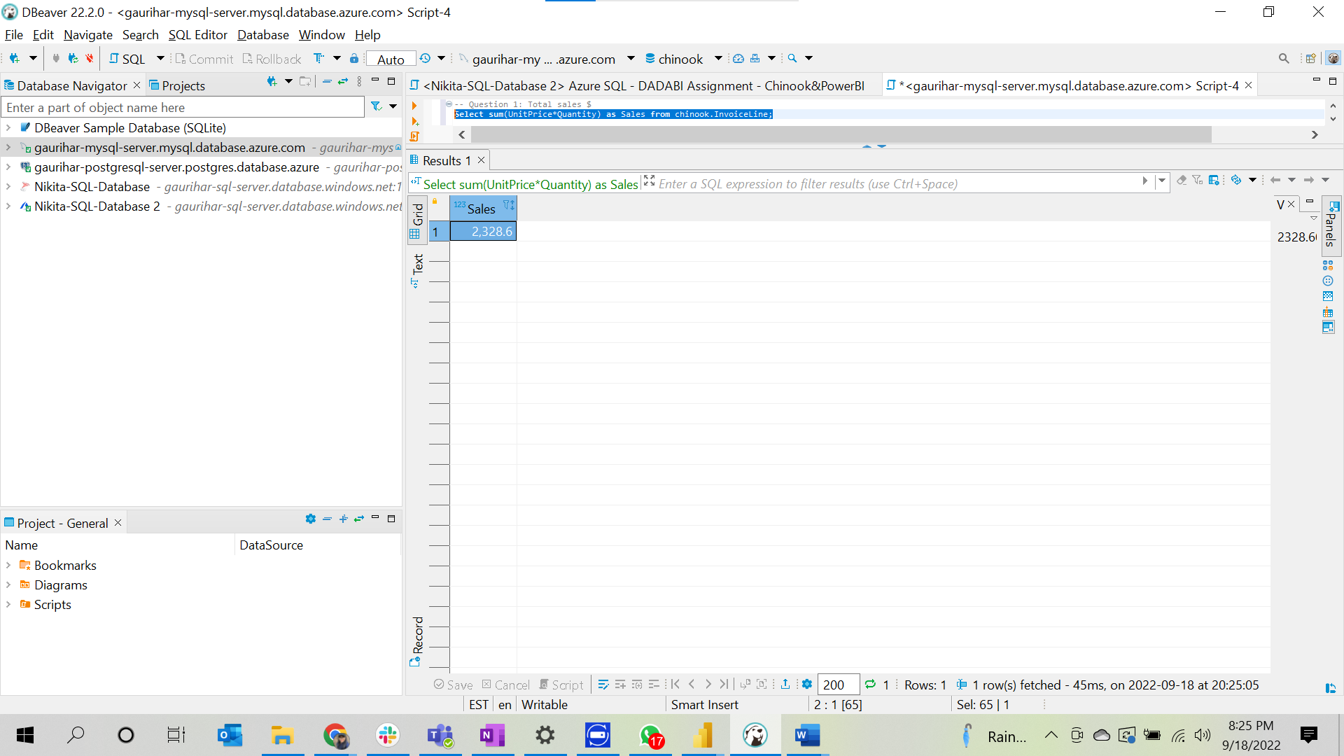

--Question 2: Total sales $ **by** country – ranked (**or** **at** **least** sorted largest **to** smallest)

**Select** invo.BillingCountry **as** Country, **sum**( involi.Quantity * involi.UnitPrice ) **as** SalesByCountry

**from** chinook.InvoiceLine involi

**join** chinook.Invoice invo **on** invo.InvoiceId = involi.InvoiceId

**group** **by** invo.BillingCountry

**order** **by** SalesByCountry **desc**;

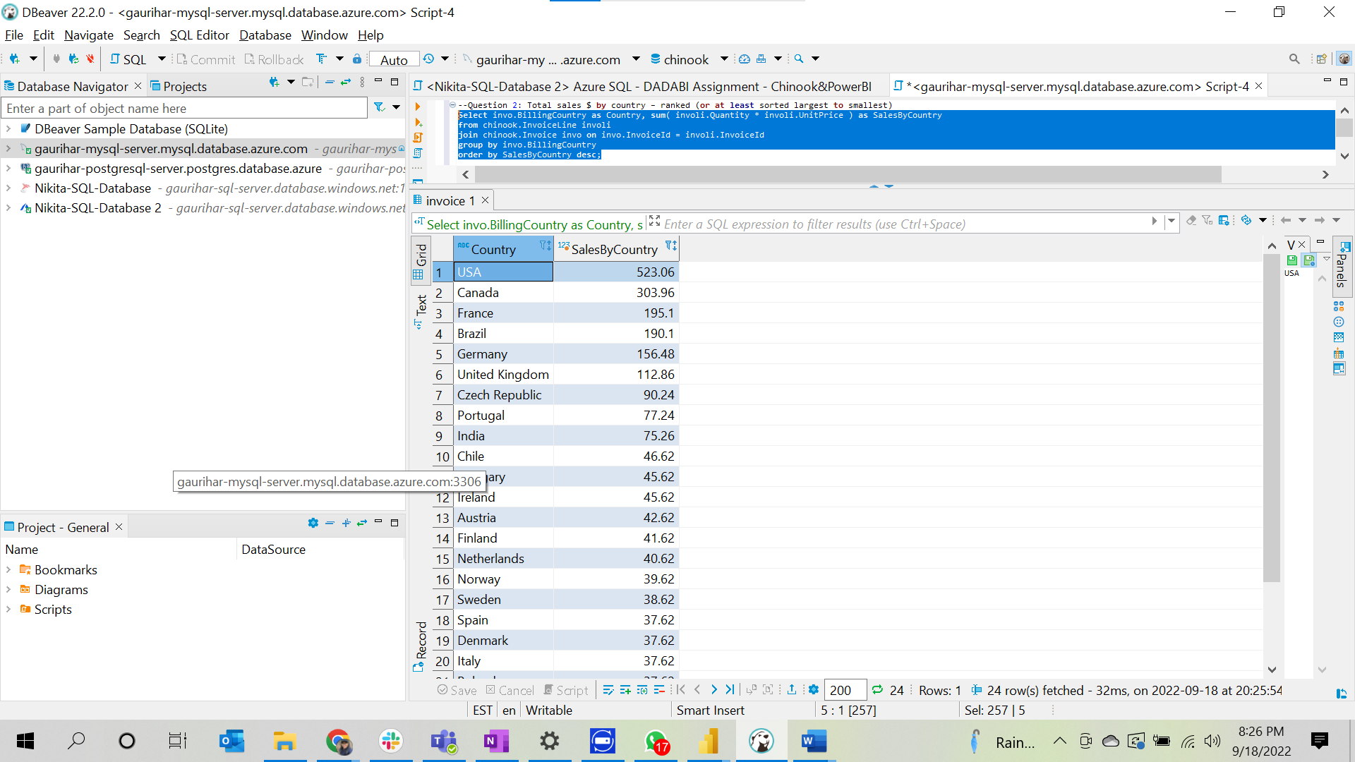

--Question 3: Total sales $ **by** country, state & city

**Select** invo.BillingCountry **as** Country,

**case** **when** invo.BillingState **is** **null** **then** invo.BillingCity

**else** invo.BillingState **end** State

, invo.BillingCity City,

**sum**( involi.Quantity * involi.UnitPrice ) SalesByCountryStateCity

**from** chinook.InvoiceLine involi **join**

chinook.Invoice invo **on** invo.InvoiceId = involi.InvoiceId

**group** **by** invo.BillingCountry,

**case**

**when** invo.BillingState **is** **null** **then** invo.BillingCity

**else** invo.BillingState **end**

, invo.BillingCity

**order** **by** State,SalesByCountryStateCity **desc**;

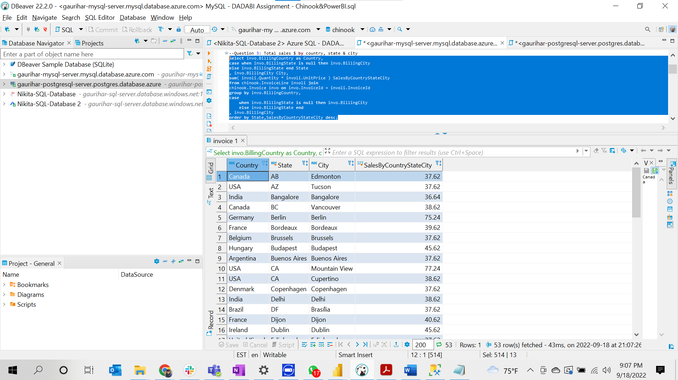

--Question 4: Total sales $ **by** customer (a person **with** **last** name & **first** name) – ranked (**or** **at** **least** sorted largest **to** smallest)

**Select** **concat**(cust.LastName, cust.FirstName) **as** FullName, **sum**(involi.Quantity * involi.UnitPrice) **as** SalesByCustomer

**from** chinook.InvoiceLine involi **join** chinook.Invoice invo

**on** involi.InvoiceId = invo.InvoiceId

**join** chinook.Customer cust

**on** cust.CustomerId = invo.CustomerId

**group** **by** **concat**(cust.LastName, cust.FirstName)

**order** **by** **sum**(involi.Quantity * involi.UnitPrice) **desc**;

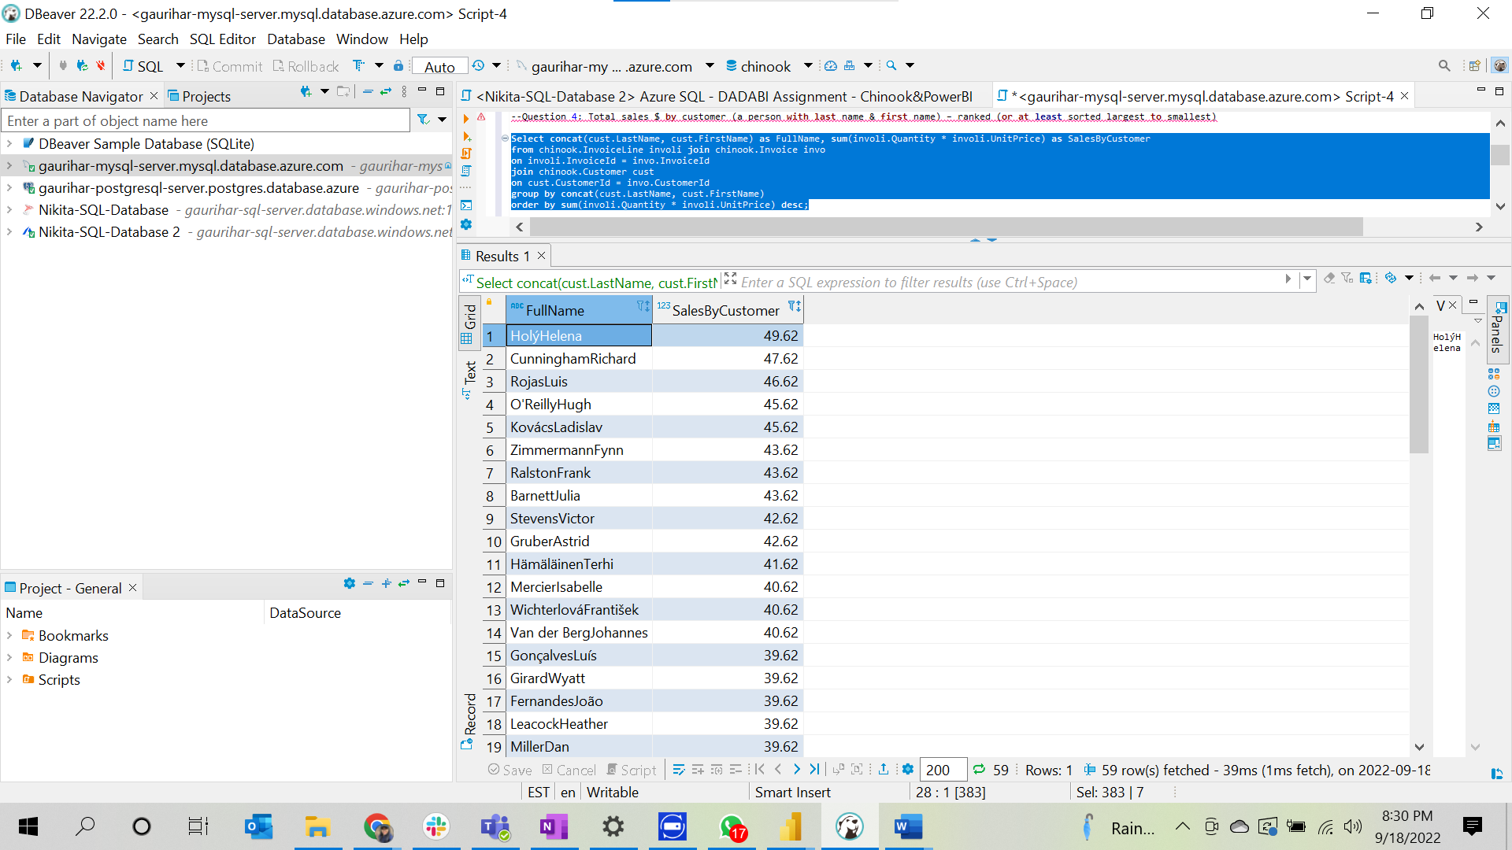

--Question 5. Total sales $ **by** artist – ranked (**or** **at** **least** sorted largest **to** smallest)

**Select** art.Name **as** ArtistName, **sum**(involi.UnitPrice * involi.Quantity) **as** SalesByArtist

**from** chinook.Artist art **join** chinook.Album ab **on** art.ArtistId = ab.ArtistId

**join** chinook.Track tr **on** tr.AlbumId = ab.AlbumId

**join** chinook.InvoiceLine involi **on** involi.TrackId = tr.TrackId

**group** **by** art.Name

**order** **by** SalesByArtist **desc**;

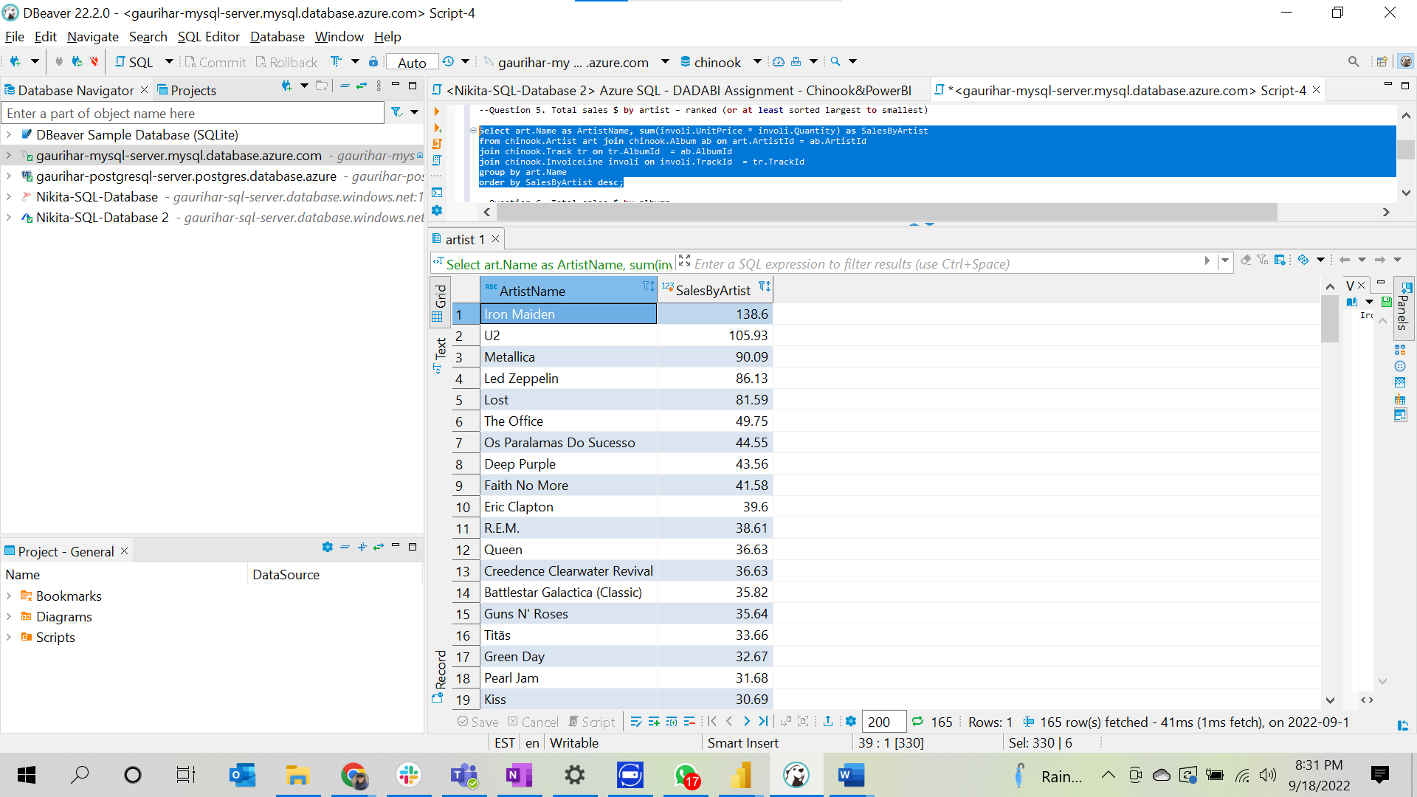

--Question 6. Total sales $ **by** albums

**Select** ab.Title **as** Album_Name,**sum**(involi.UnitPrice * involi.Quantity) SalesByAlbum

**from** chinook.Album ab **join** chinook.Track tr **on** ab.AlbumId = tr.AlbumId

**join** chinook.InvoiceLine involi **on** involi.TrackId = tr.TrackId

**group** **by** ab.Title

**order** **by** SalesByAlbum **desc**;

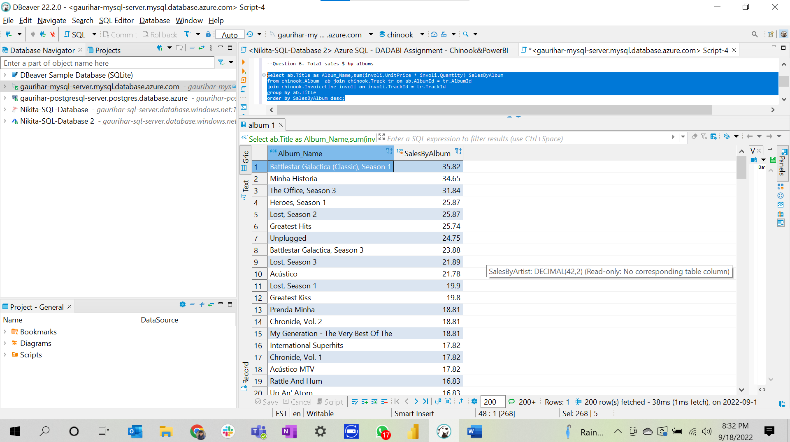

--Question 7. Total sales $ **by** salesperson (employee)

**Select** **concat**(emp.LastName, emp.FirstName) **as** SalesPerson, **sum**(involi.UnitPrice * involi.Quantity) SalesBySalesperson

**from** chinook.Employee emp **join** chinook.Customer cust **on** emp.EmployeeId = cust.SupportRepId

**join** chinook.Invoice invo **on** invo.CustomerId = cust.CustomerId

**join** chinook.InvoiceLine involi **on** involi.InvoiceId = invo.InvoiceId

**group** **by** **concat**(emp.LastName, emp.FirstName)

**order** **by** SalesBySalesperson **desc**;

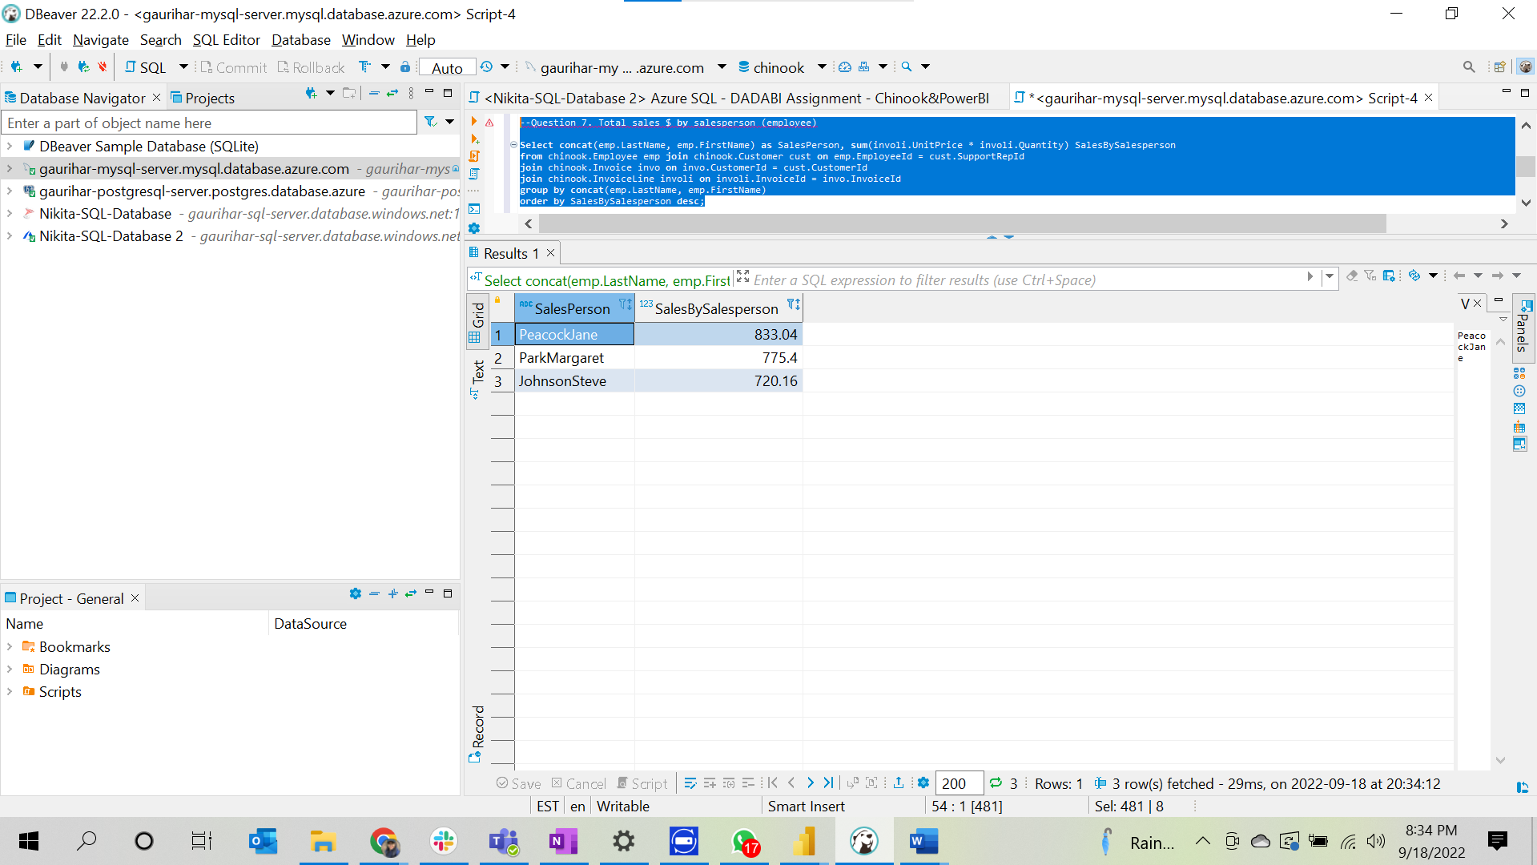

-- Question 8: Total tracks bought and total revenue $ by media type

**Select** mt.Name **as** MediaType, **SUM**(il.Quantity*il.UnitPrice) **as** Sales, **SUM**(il.Quantity)

**from** chinook.MediaType mt **join** chinook.Track t **on** mt.MediaTypeId = t.MediaTypeId **join** chinook.InvoiceLine il **on** t.TrackId = il.TrackId

**group** **by** mt.Name, il.Quantity ;

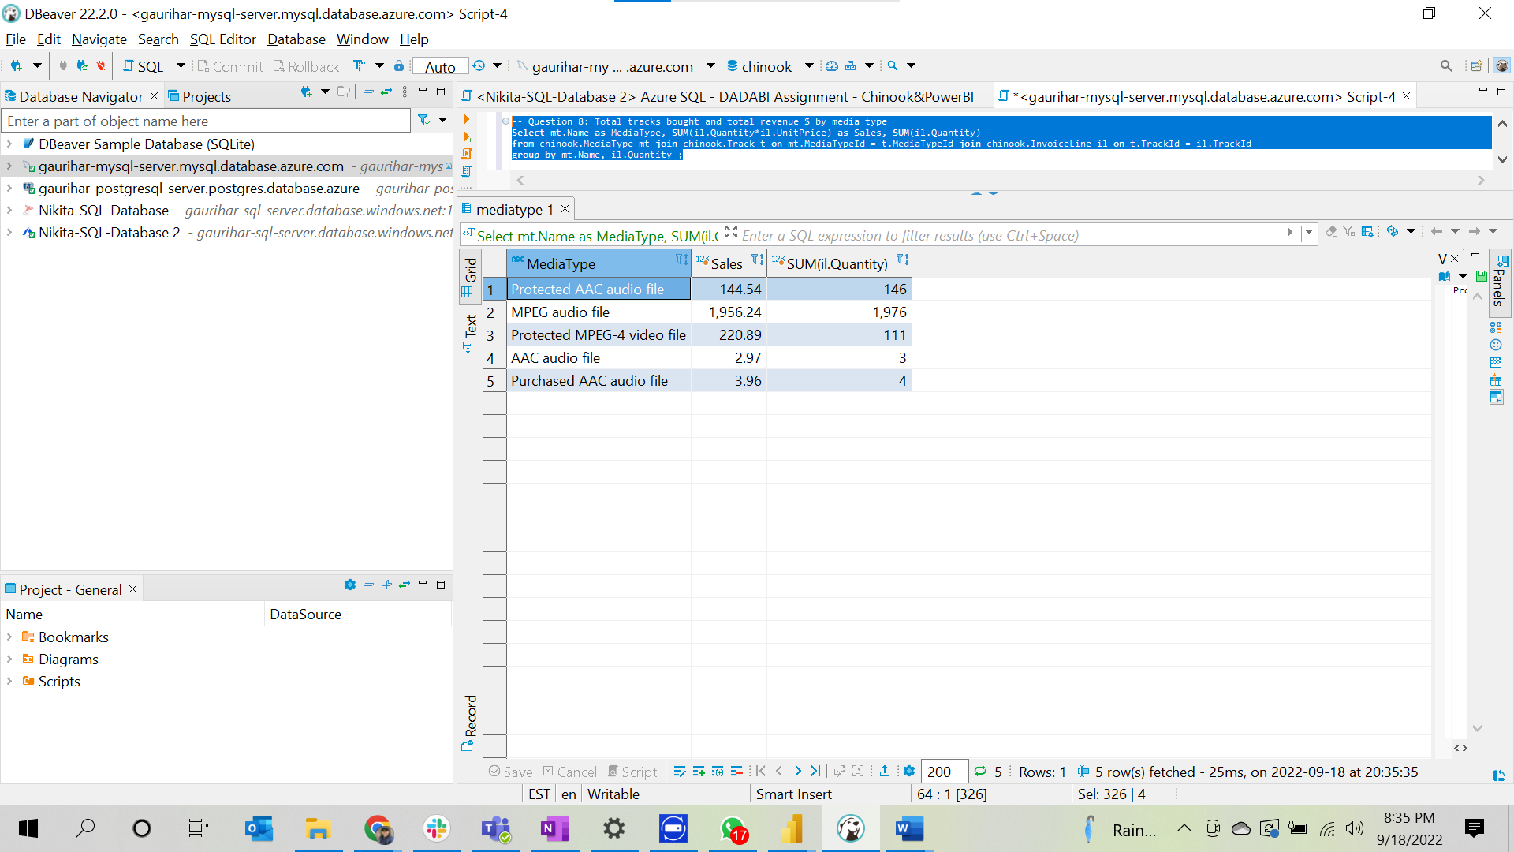

--Question 9: Total sales $ **by** genre

**Select** gen.Name **as** GenreName, **SUM**(involi.Quantity * involi.UnitPrice) **as** SalesByGenre

**from** chinook.Genre gen

**join** chinook.Track t **on** gen.GenreId = t.GenreId

**join** chinook.InvoiceLine involi **on** t.TrackId = involi.TrackId

**group** **by** gen.Name;

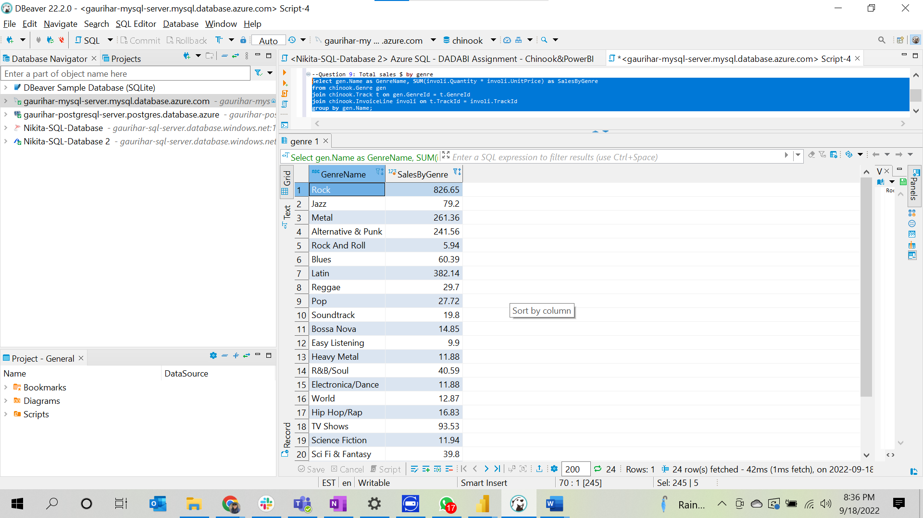

--Question 10: Total sales $ **by** company

**Select** cus.Company **as** Company_Name, **sum**(involi.UnitPrice * involi.Quantity) SalesByCompany

**from** chinook.Customer cus

**join** chinook.Invoice invo **on** cus.CustomerId = invo.CustomerId

**join** chinook.InvoiceLine involi **on** involi.InvoiceId = invo.InvoiceId

**where** cus.Company **is** **not** **null**

**group** **by** cus.Company

**order** **by** SalesByCompany **desc**;

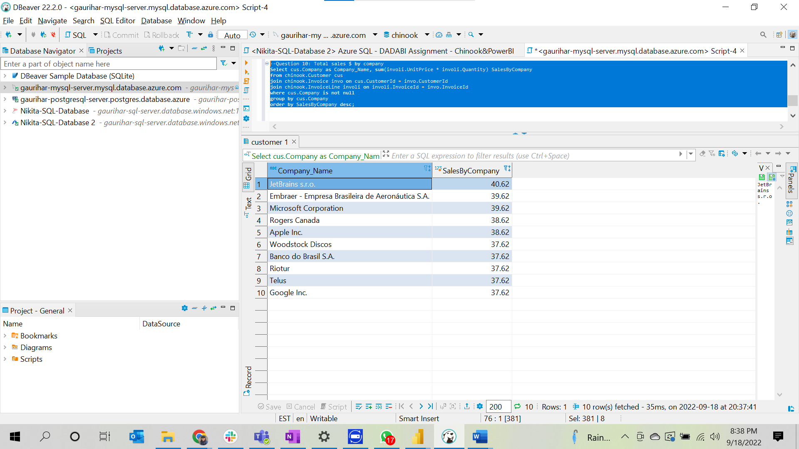

1. **PostGre SQL Server**

-- Question 1: Total sales $

**Select** **sum**(il."UnitPrice" * il."Quantity") **as** Sales **from** "InvoiceLine" il;

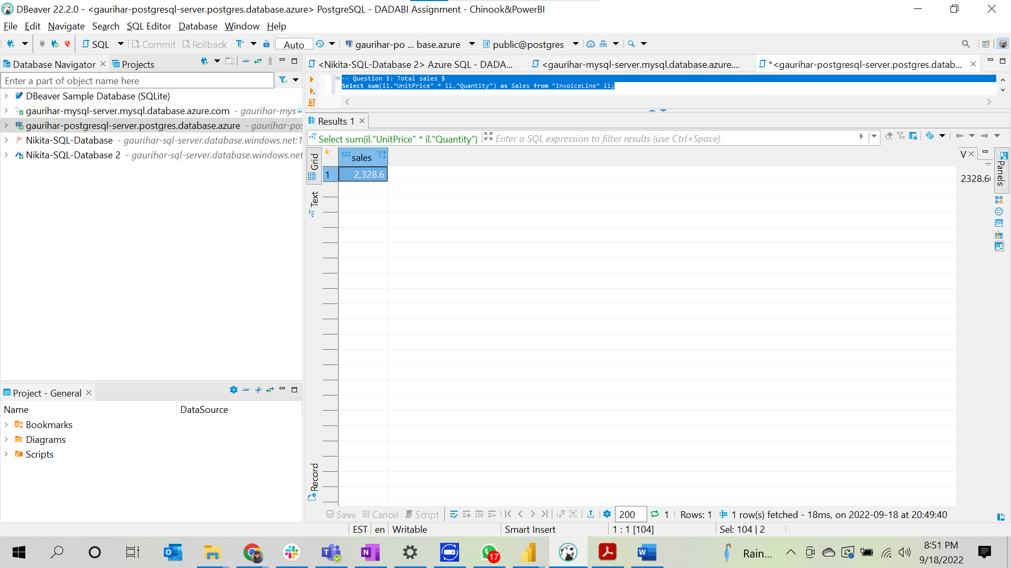

--Question 2: Total sales $ by country – ranked (or at least sorted largest to smallest)

**Select** invo."BillingCountry" **as** Country, **sum**( involi."Quantity" * involi."UnitPrice" ) **as** SalesByCountry

**from** "InvoiceLine" involi

**join** "Invoice" invo **on** invo."InvoiceId" = involi."InvoiceId"

**group** **by** invo."BillingCountry"

**order** **by** SalesByCountry **desc**;

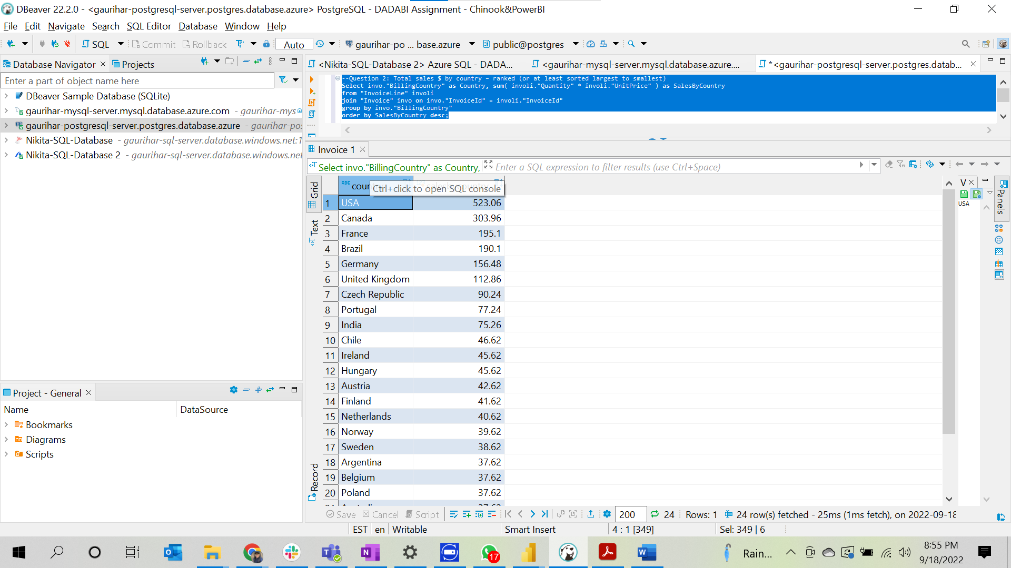

--Question 3: Total sales $ by country, state & city

**Select** invo."BillingCountry" **as** Country,

**case** **when** invo."BillingState" **is** **null** **then** invo."BillingCity"

**else** invo."BillingState" **end** State

, invo."BillingCity" City,

**sum**( involi."Quantity" * involi."UnitPrice") SalesByCountryStateCity

**from** "InvoiceLine" involi **join**

"Invoice" invo **on** invo."InvoiceId" = involi."InvoiceId"

**group** **by** invo."BillingCountry",

**case**

**when** invo."BillingState" **is** **null** **then** invo."BillingCity"

**else** invo."BillingState" **end**

, invo."BillingCity"

**order** **by** State,SalesByCountryStateCity **desc**;

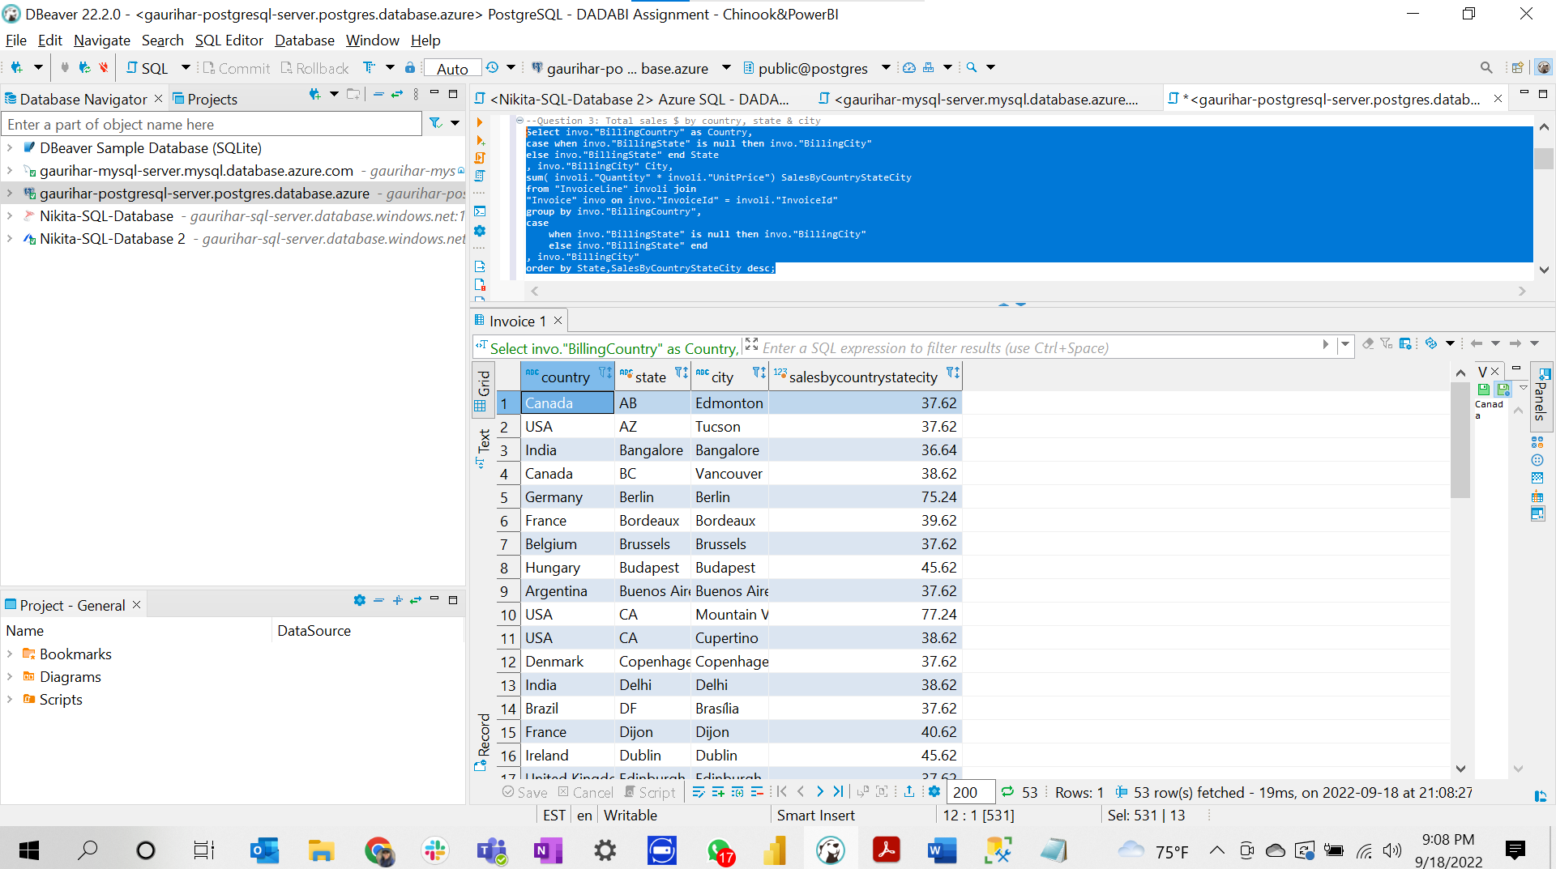

--Question 4: Total sales $ by customer (a person with last name & first name) – ranked (or at least sorted largest to smallest)

**Select** **concat**(cust."LastName" , cust."FirstName") **as** FullName, **sum**(involi."Quantity" * involi."UnitPrice") **as** SalesByCustomer

**from** "InvoiceLine" involi **join** "Invoice" invo

**on** involi."InvoiceId" = invo."InvoiceId"

**join** "Customer" cust

**on** cust."CustomerId" = invo."CustomerId"

**group** **by** **concat**(cust."LastName" , cust."FirstName")

**order** **by** **sum**(involi."Quantity" * involi."UnitPrice") **desc**;

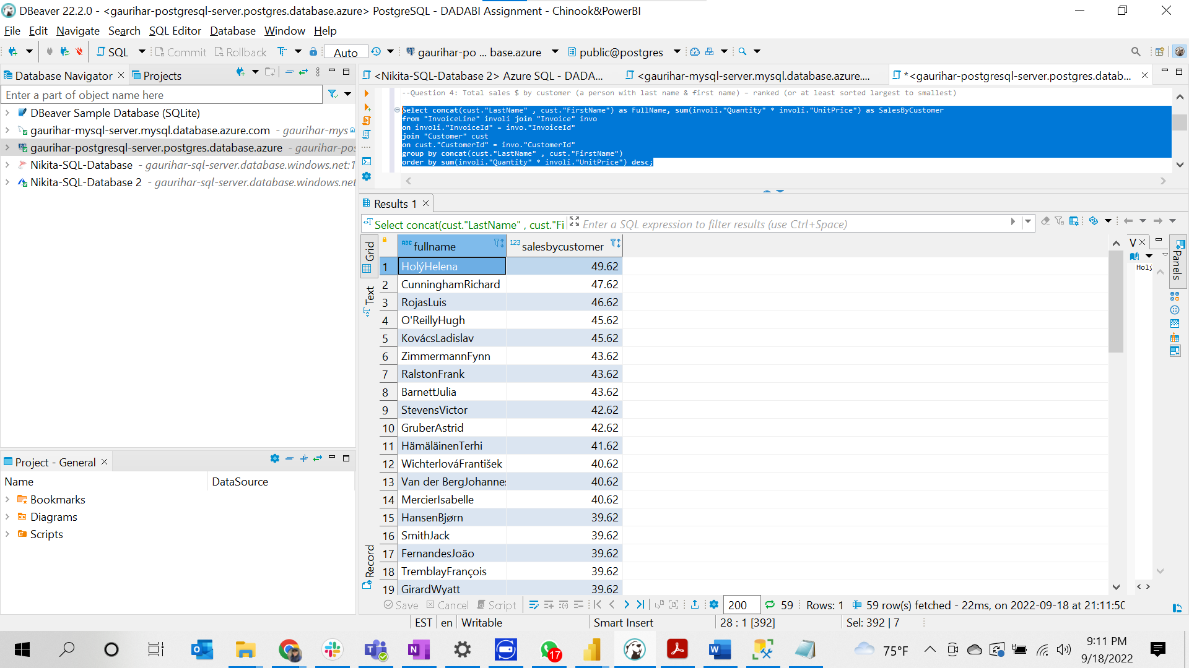

--Question 5. Total sales $ by artist – ranked (or at least sorted largest to smallest)

**Select** art."Name" **as** ArtistName, **sum**(involi."Quantity" * involi."UnitPrice") **as** SalesByArtist

**from** "Artist" art **join** "Album" ab **on** art."ArtistId" = ab."ArtistId"

**join** "Track" tr **on** tr."AlbumId" = ab."AlbumId"

**join** "InvoiceLine" involi **on** involi."TrackId" = tr."TrackId"

**group** **by** art."Name"

**order** **by** SalesByArtist **desc**;

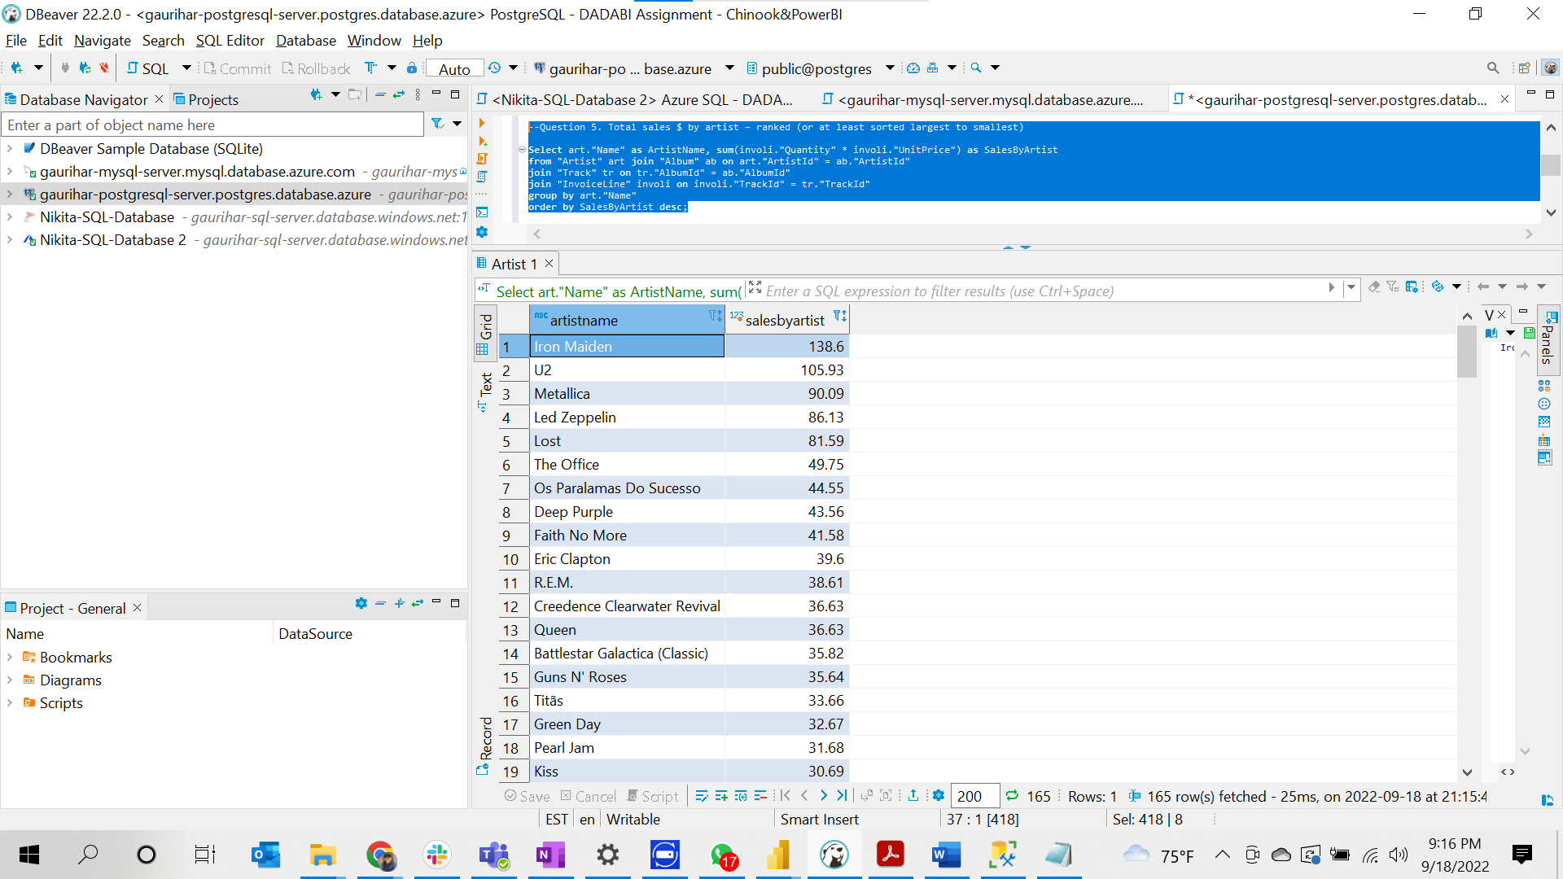

--Question 6. Total sales $ by albums

**Select** ab."Title" **as** Album_Name,**sum**(involi."Quantity" * involi."UnitPrice") SalesByAlbum

**from** "Album" ab **join** "Track" tr **on** ab."AlbumId" = tr."AlbumId"

**join** "InvoiceLine" involi **on** involi."TrackId" = tr."TrackId"

**group** **by** ab."Title"

**order** **by** SalesByAlbum **desc**;

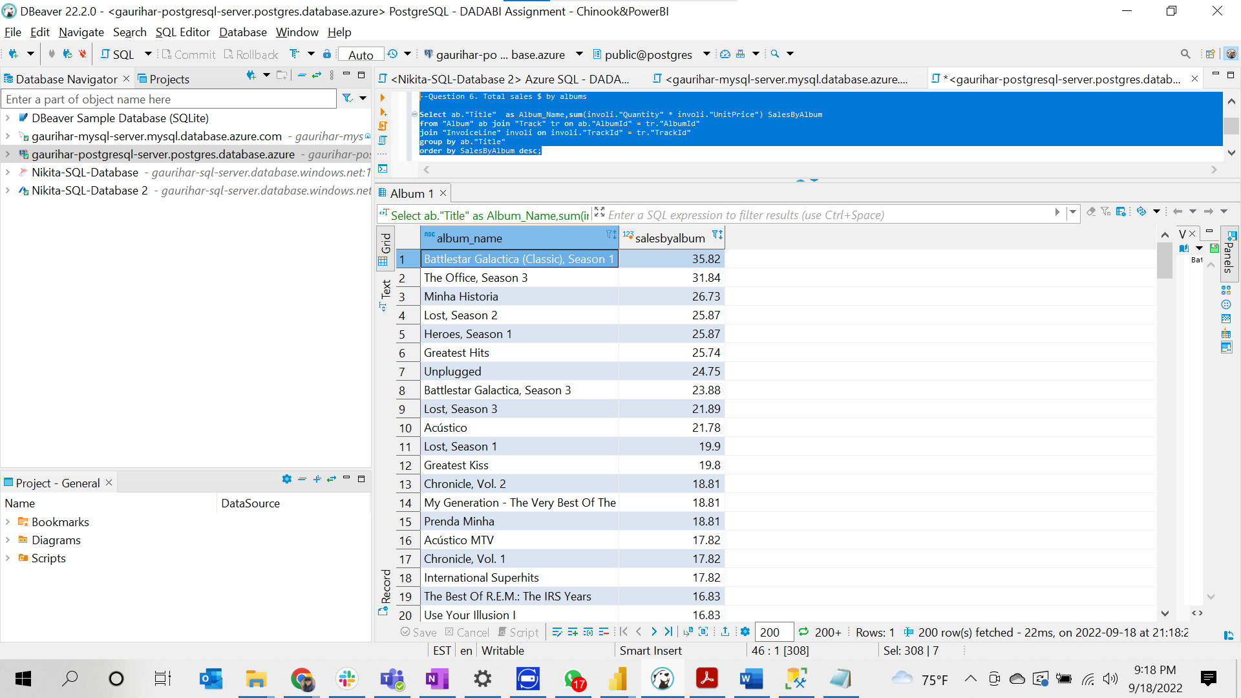

--Question 7. Total sales $ by salesperson (employee)

**Select** **concat**(emp."LastName", emp."FirstName") **as** SalesPerson, **sum**(involi."Quantity" * involi."UnitPrice") SalesBySalesperson

**from** "Employee" emp **join** "Customer" cust **on** emp."EmployeeId" = cust."SupportRepId"

**join** "Invoice" invo **on** invo."CustomerId" = cust."CustomerId"

**join** "InvoiceLine" involi **on** involi."InvoiceId" = invo."InvoiceId"

**group** **by** **concat**(emp."LastName", emp."FirstName")

**order** **by** SalesBySalesperson **desc**;

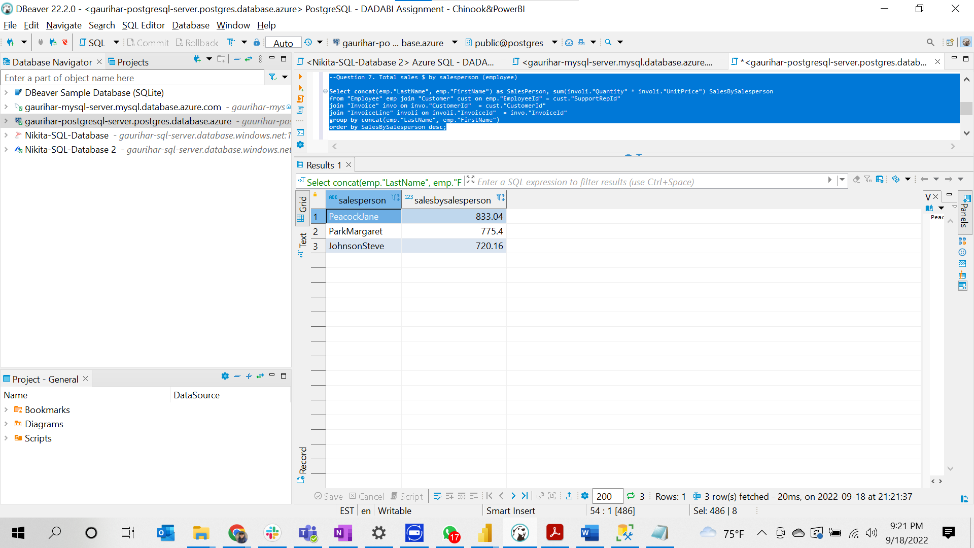

-- Question 8: Total tracks bought and total revenue $ by media type

**Select** mt."Name" **as** MediaType, **sum**(involi."Quantity" * involi."UnitPrice") **as** Sales, **SUM**(involi."Quantity")

**from** "MediaType" mt **join** "Track" t **on** mt."MediaTypeId" = t."MediaTypeId" **join** "InvoiceLine" involi **on** t."TrackId" = involi."TrackId"

**group** **by** mt."Name", involi."Quantity" ;

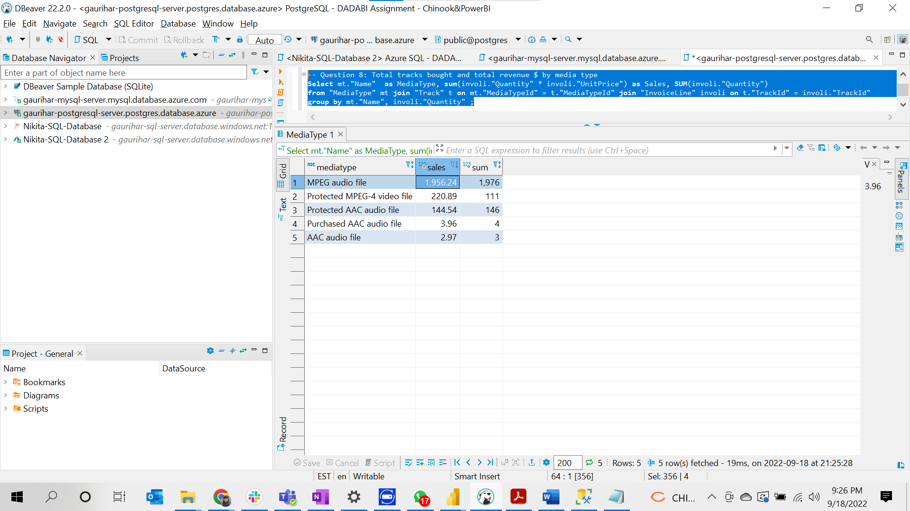

--Question 9: Total sales $ by genre

**Select** gen."Name" **as** GenreName, **SUM**(involi."Quantity" * involi."UnitPrice") **as** SalesByGenre

**from** "Genre" gen

**join** "Track" t **on** gen."GenreId" = t."GenreId"

**join** "InvoiceLine" involi **on** t."TrackId" = involi."TrackId"

**group** **by** gen."Name";

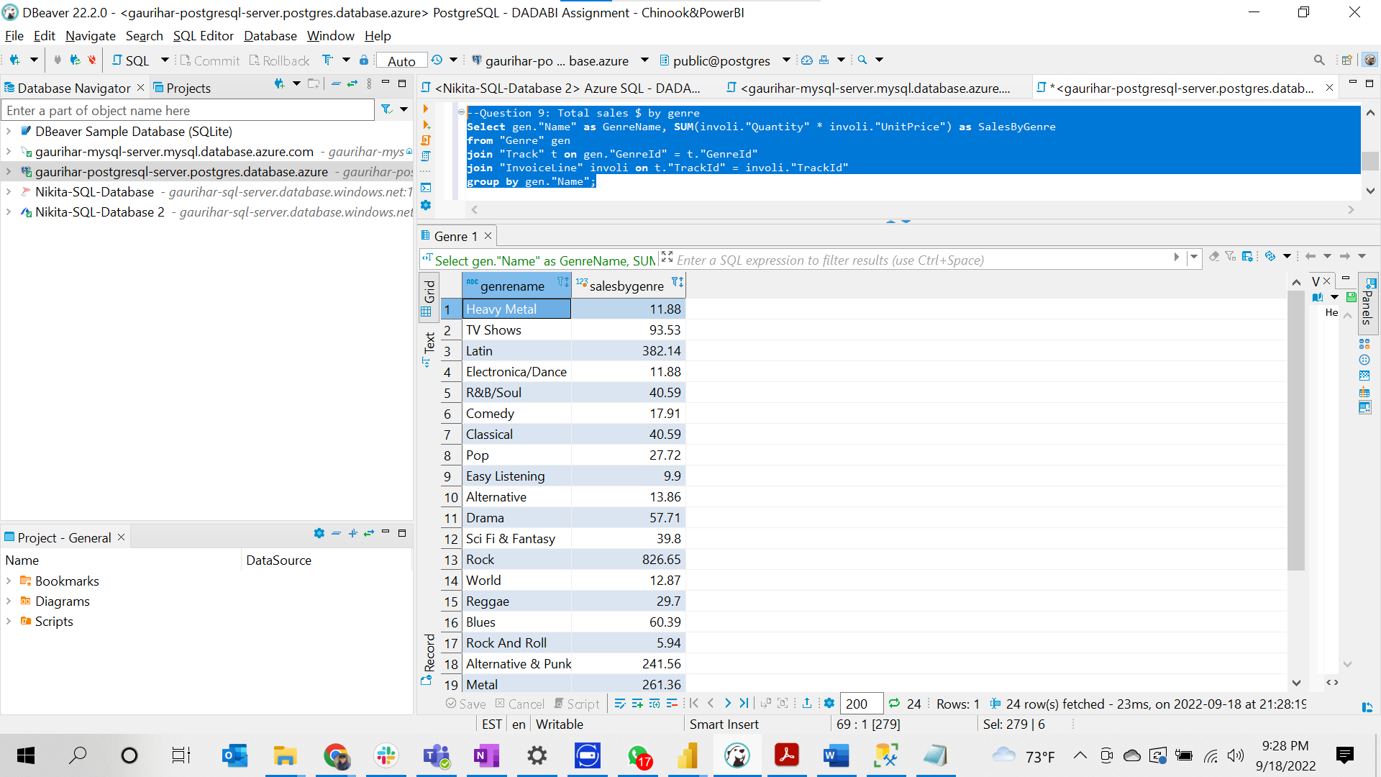

--Question 10: Total sales $ by company

**Select** cus."Company" **as** Company_Name, **sum**(involi."Quantity" * involi."UnitPrice") SalesByCompany

**from** "Customer" cus

**join** "Invoice" invo **on** cus."CustomerId" = invo."CustomerId"

**join** "InvoiceLine" involi **on** involi."InvoiceId" = invo."InvoiceId"

**where** cus."Company" **is** **not** **null**

**group** **by** cus."Company"

**order** **by** SalesByCompany **desc**;

